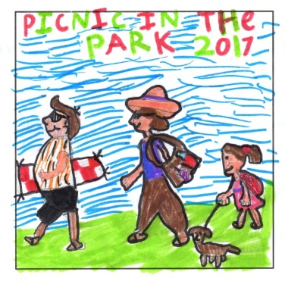
Picnic in the Park - Sunday 28th May 2017
RAFFLE PRIZES
• DAY BOAT HIRE – ALVECHURCH MARINA•
• Season Ticket to Alvechurch Football Club •
• Family ticket to Pantomime – Palace Theatre •
• 4 tickets – Hatton Adventure•
• 2 T20 tickets – Warwickshire CC•
• One weeks free Cambridge Weight Plan•
• 2 cinema tickets – The Artrix •
• Family ticket – Stratford Butterfly Farm •
• Webbs of Wychbold Voucher•
• Burcot Garden Centre Voucher•
With MASSIVE thanks to all who donated prizes

